Module Name: Functional & Non-Functional Testing
Test Case ID: 4
Webpage URL: https://www.automationexercise.com

● Scenario ID: 1

Scenario: Sign up with valid credential (valid ID, Password)

Test Steps:
1. Open the Website and register in website
2. Enter username and email ID
3. Enter Account Information
4. Enter Address Information
5. Click Create Account Button

ScreenShots:-

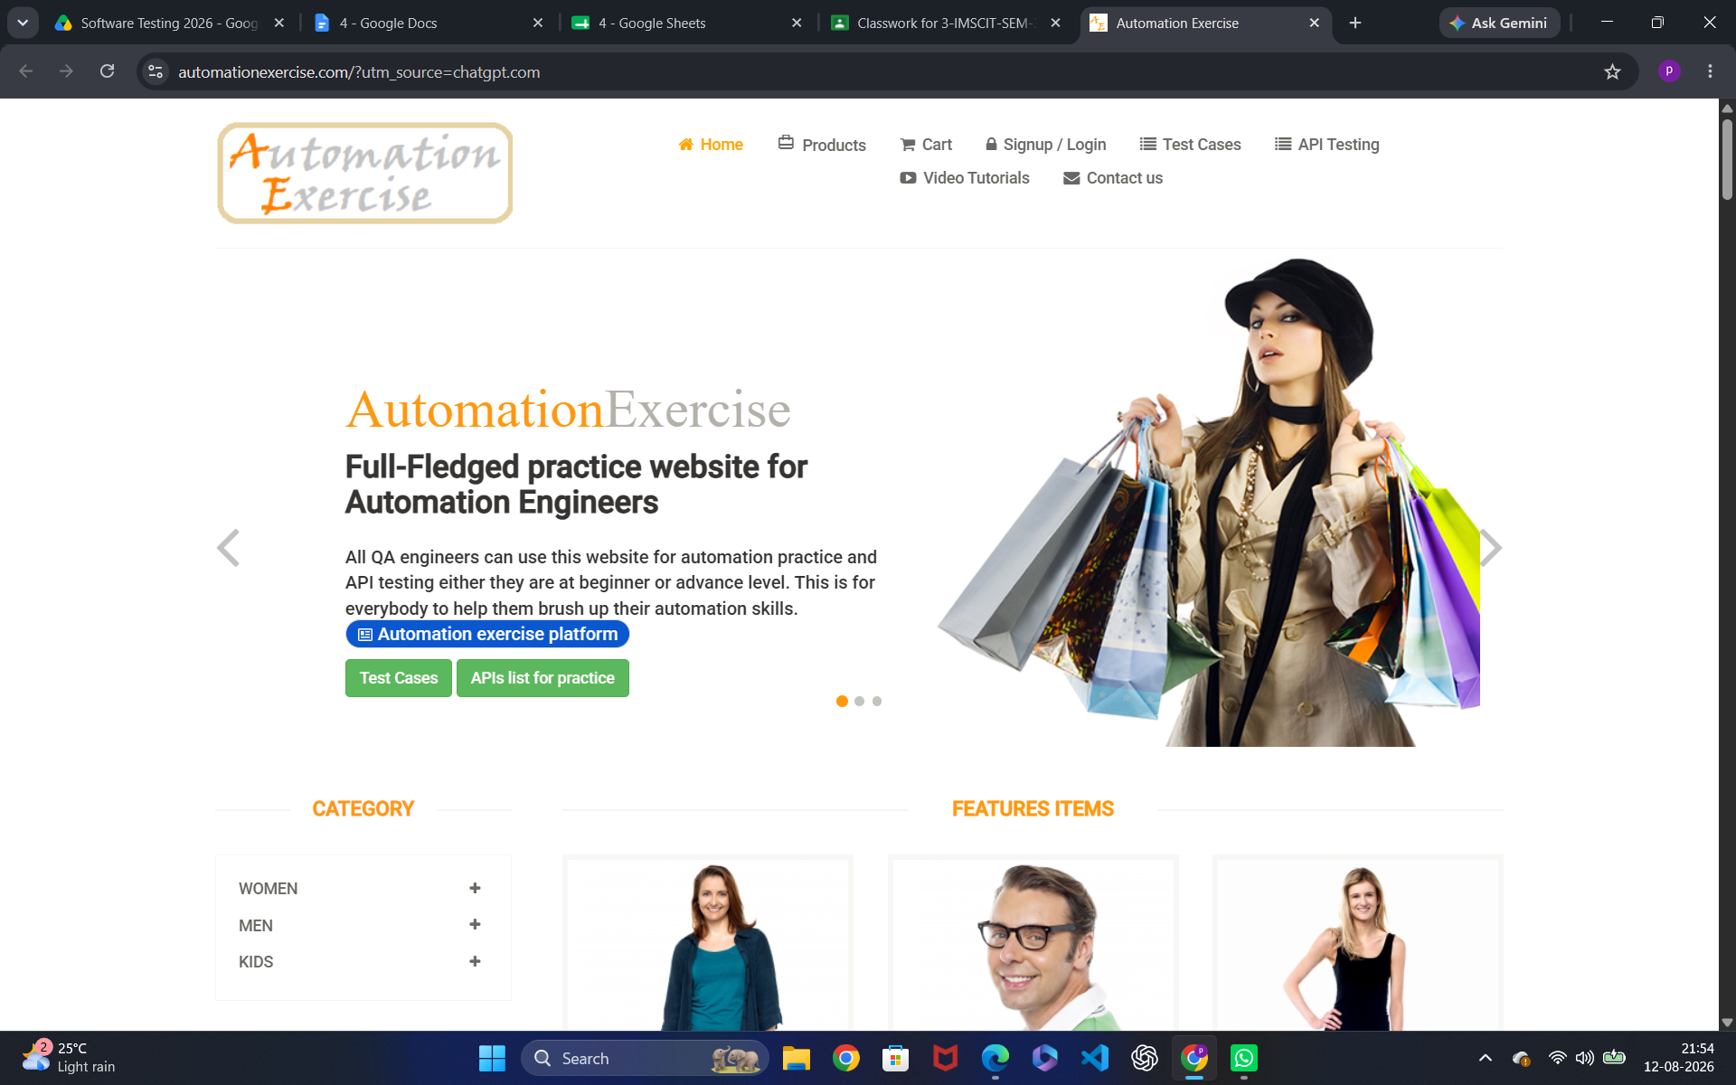

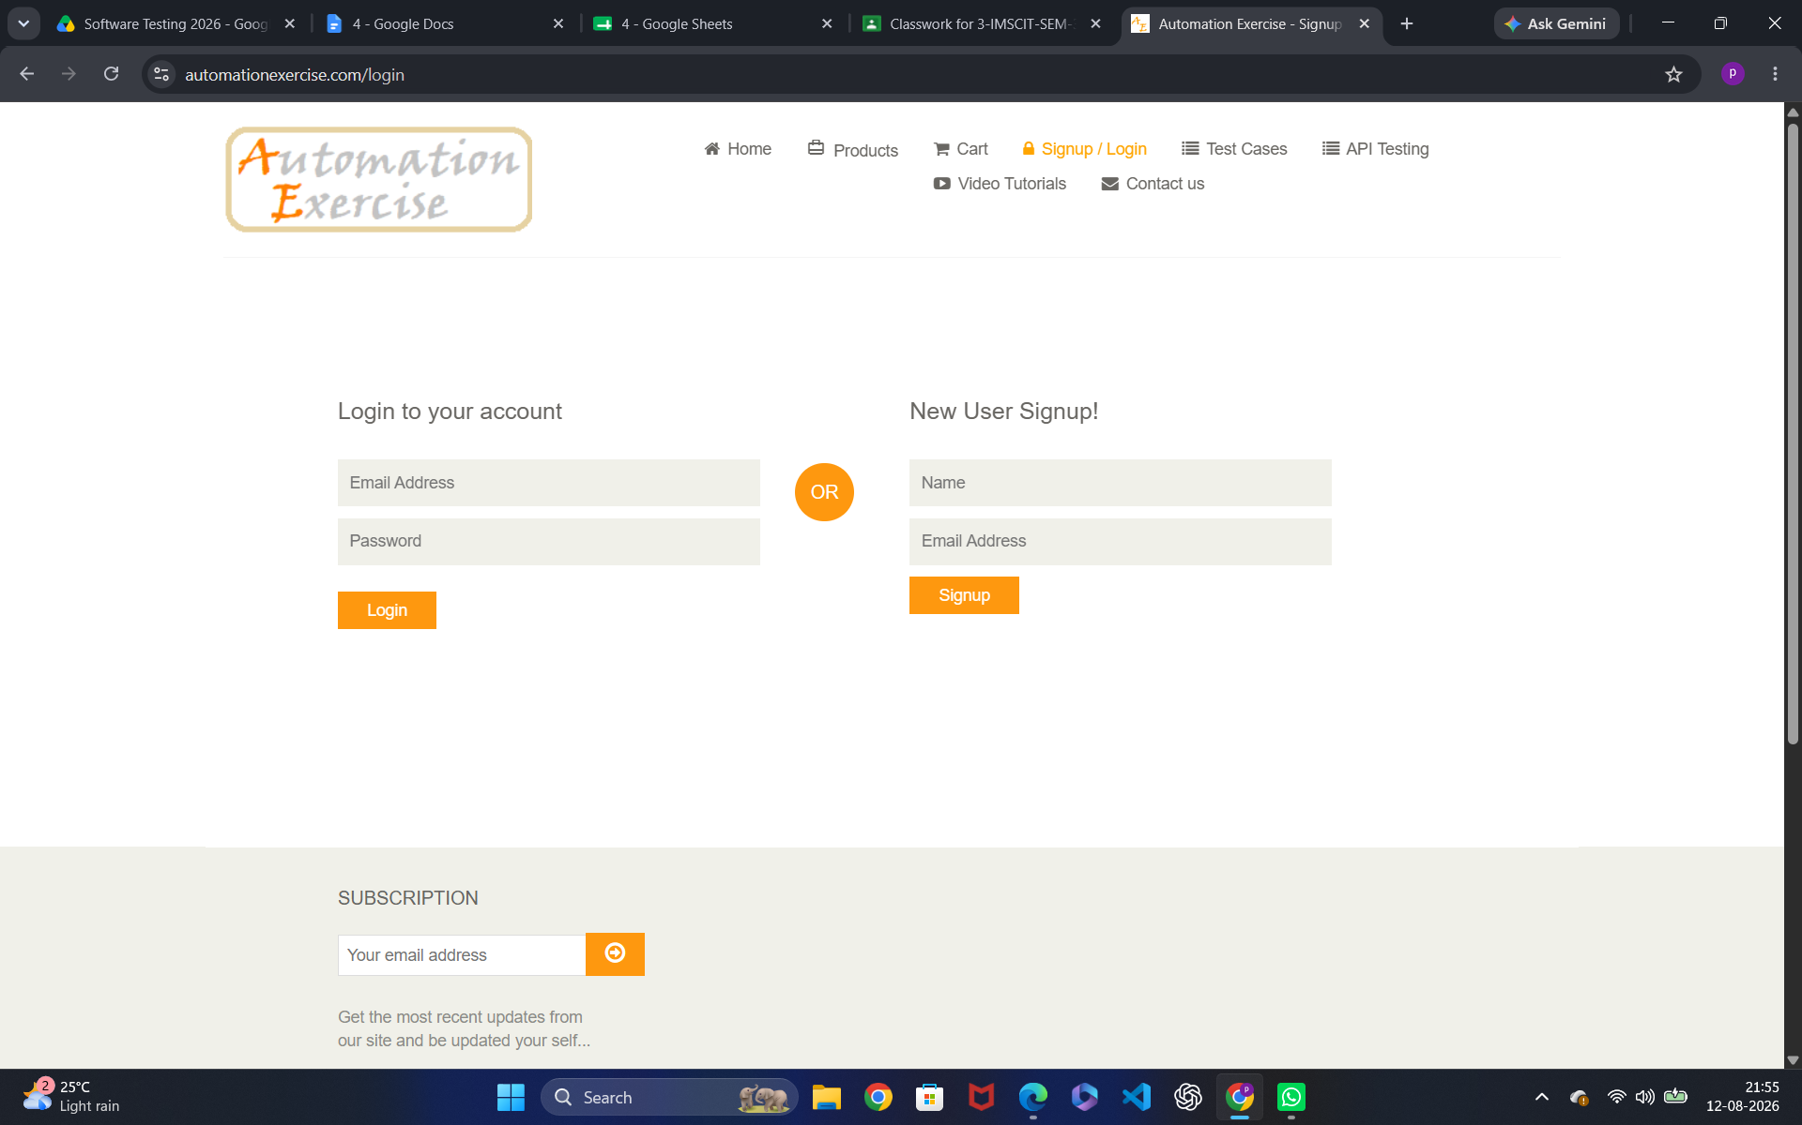

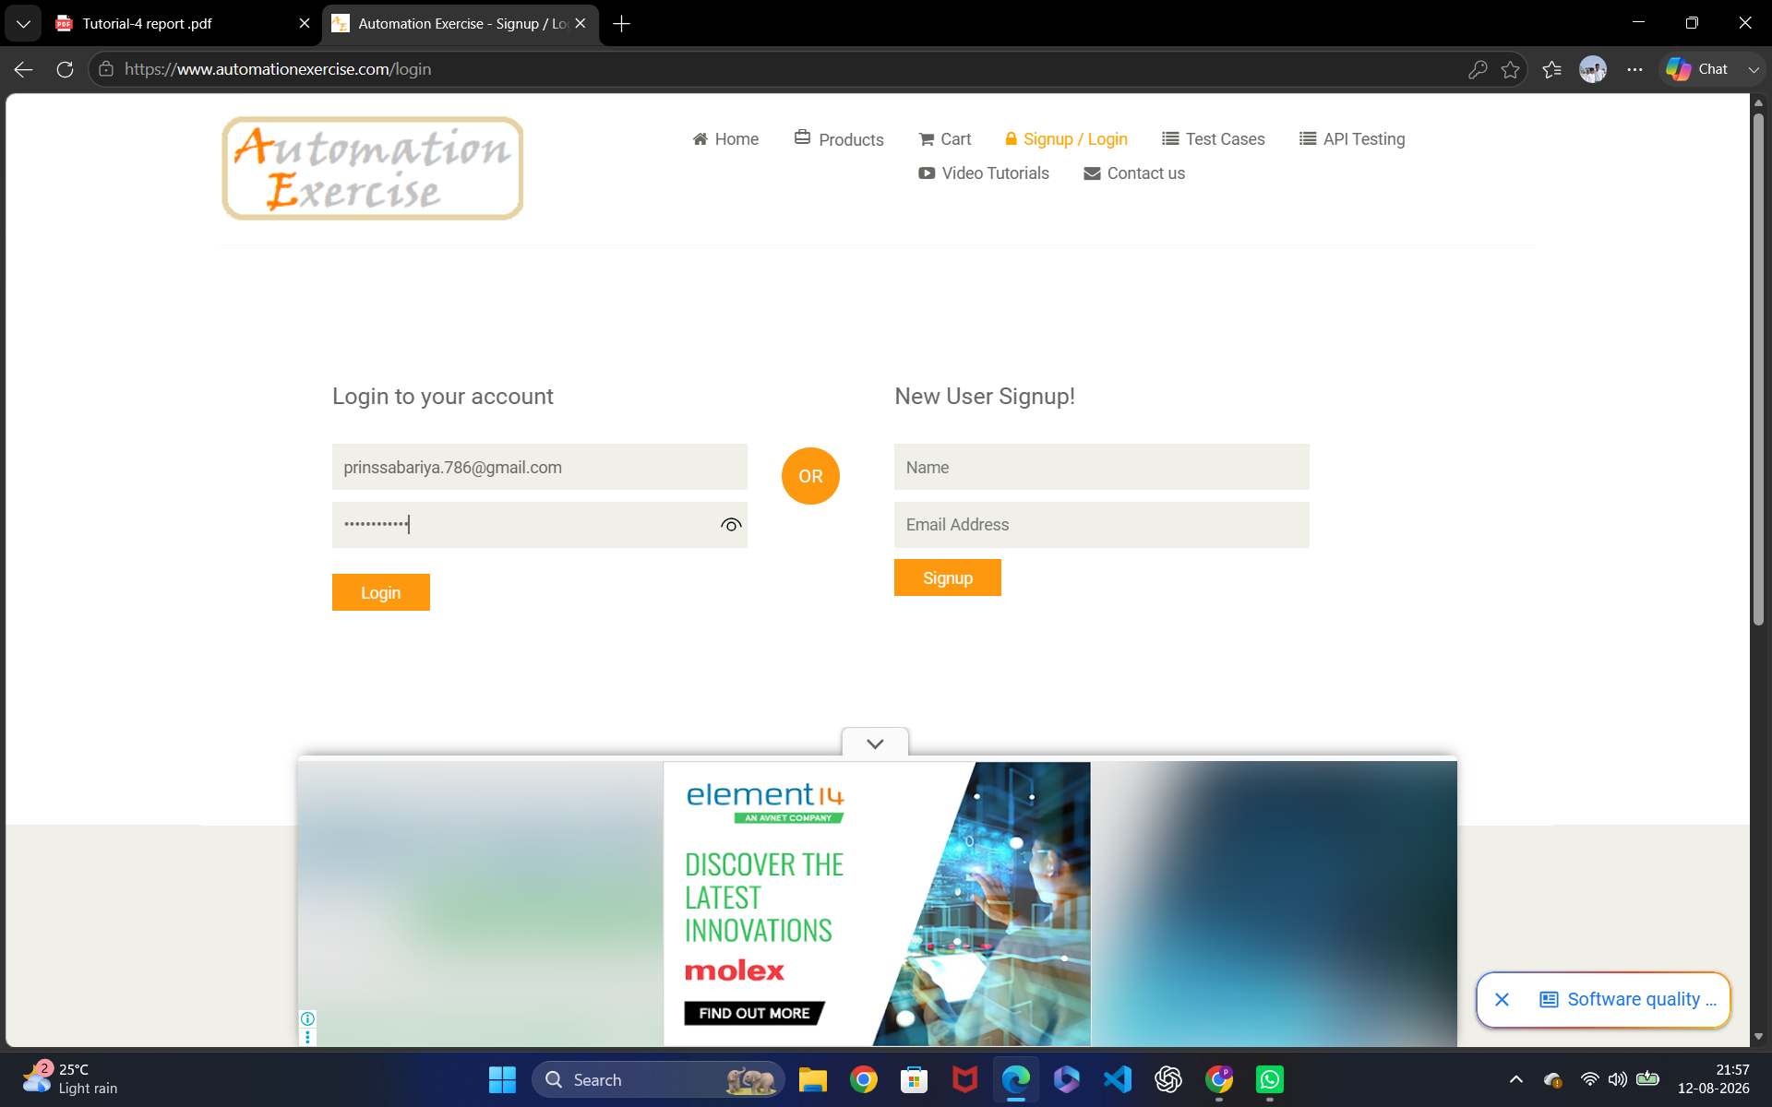

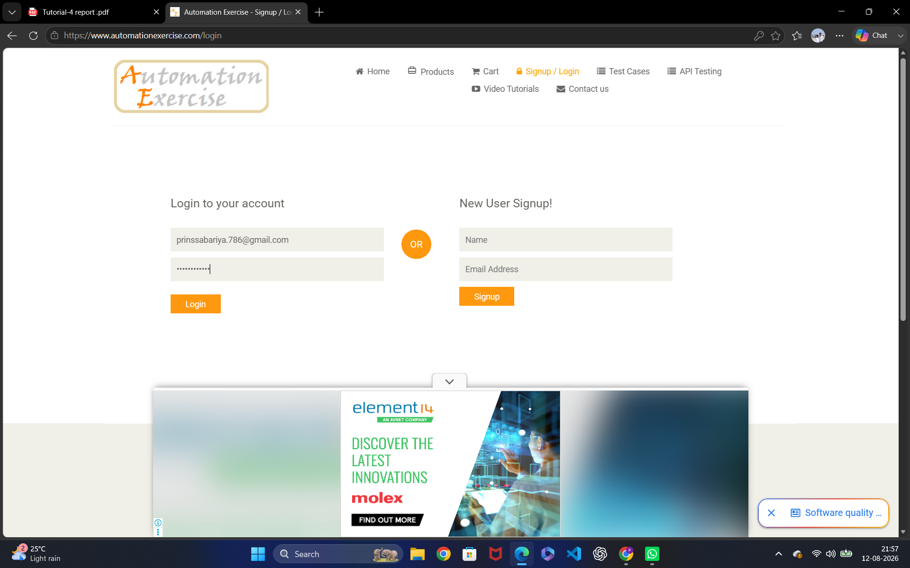

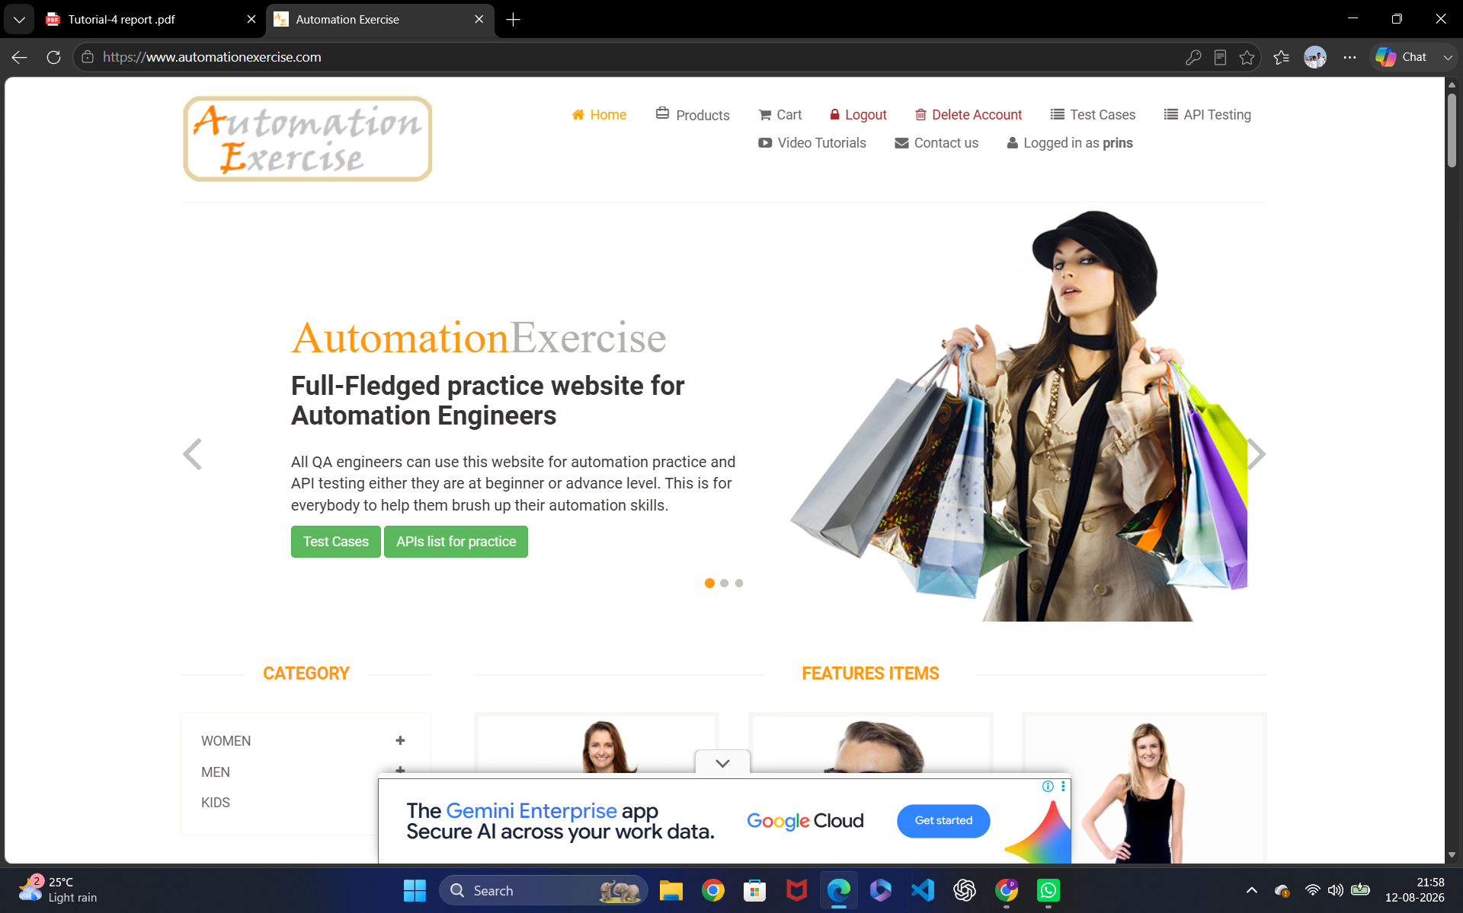

● Scenario ID: 2

Scenario: Sign up with invalid credential (invalid ID, Password)

Test Steps:

1. Open the Website and register in website
2. Enter username and email ID
3. Enter Account Information
4. Enter Address Information
5. Click Create Account Button

Screenshots:-

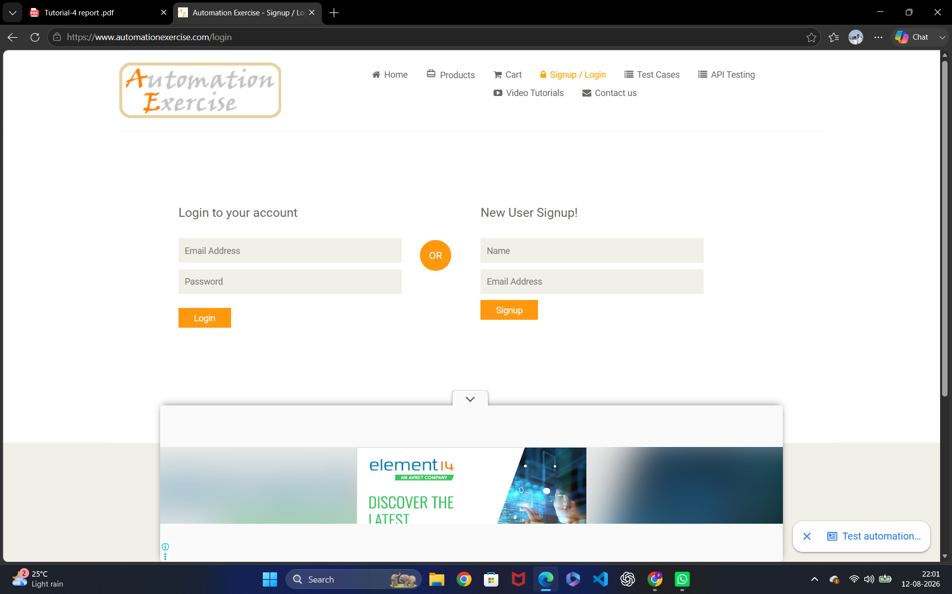

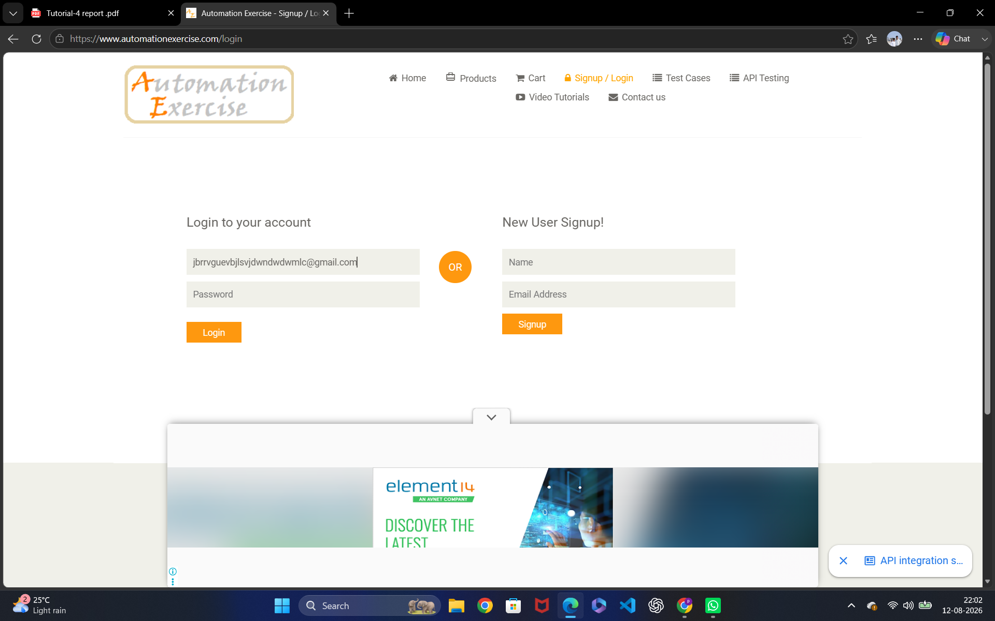

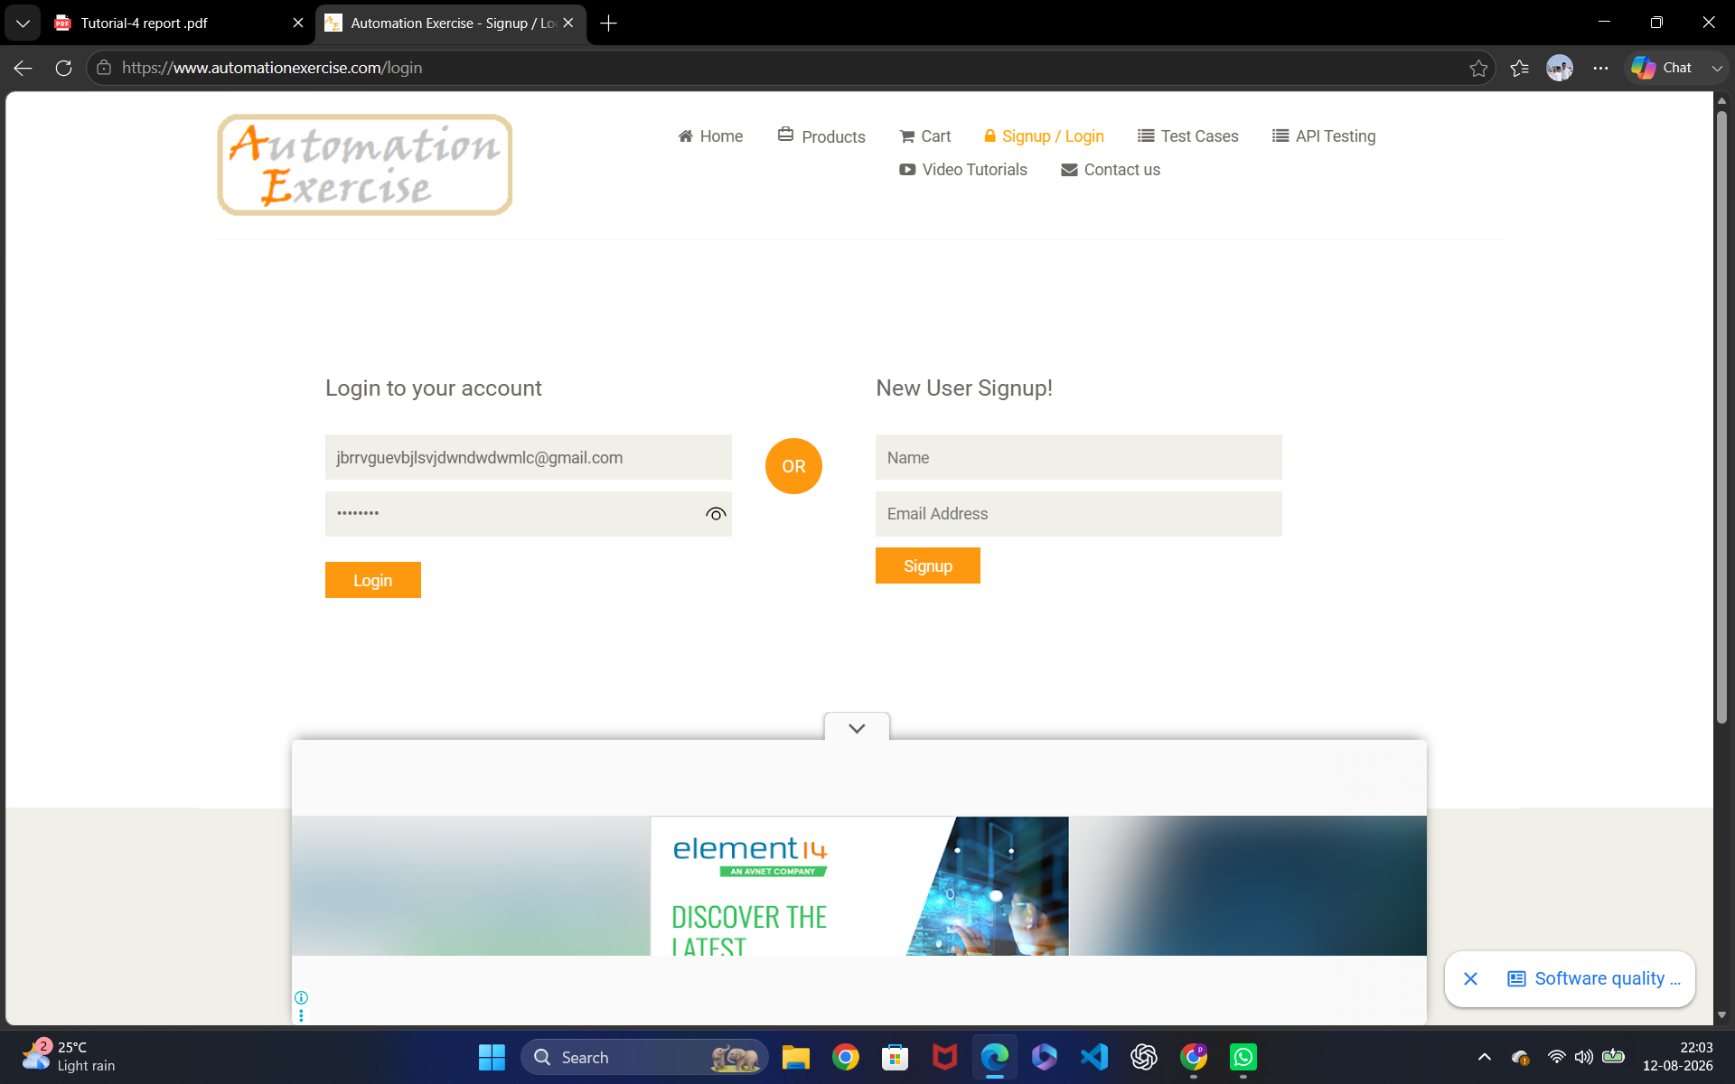
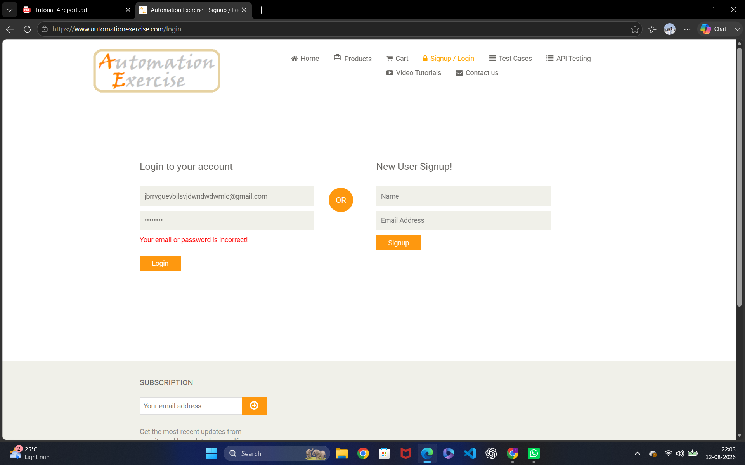

● Scenario ID: 3

Scenario: Both invalid credential

Test Steps:
1. Open the website and register in website
2. Enter Invalid email
3. Enter Invalid password
4. Click login

Screenshots:-

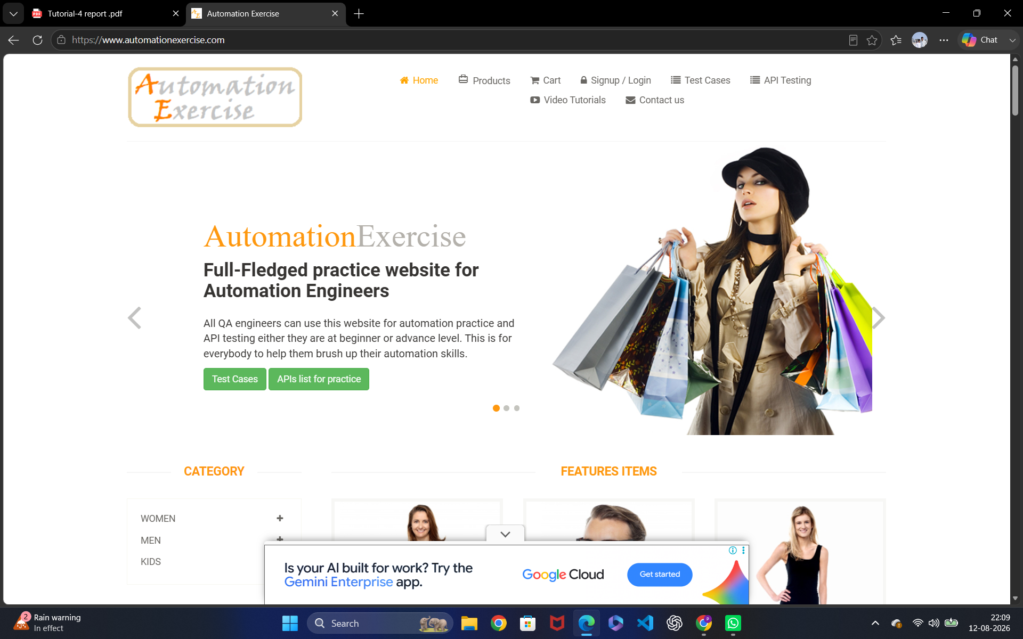

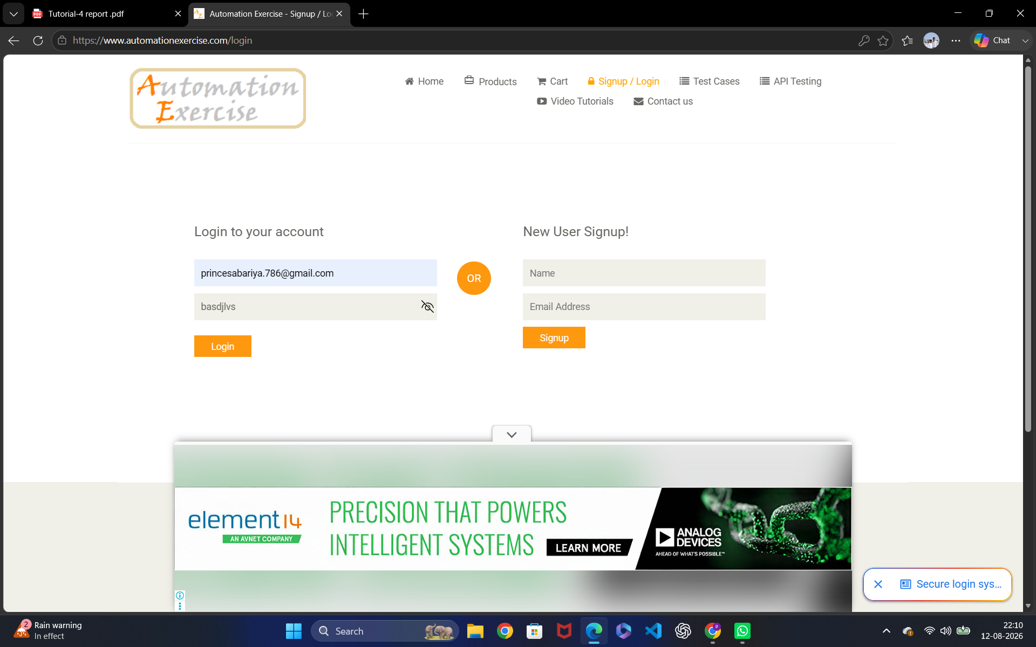

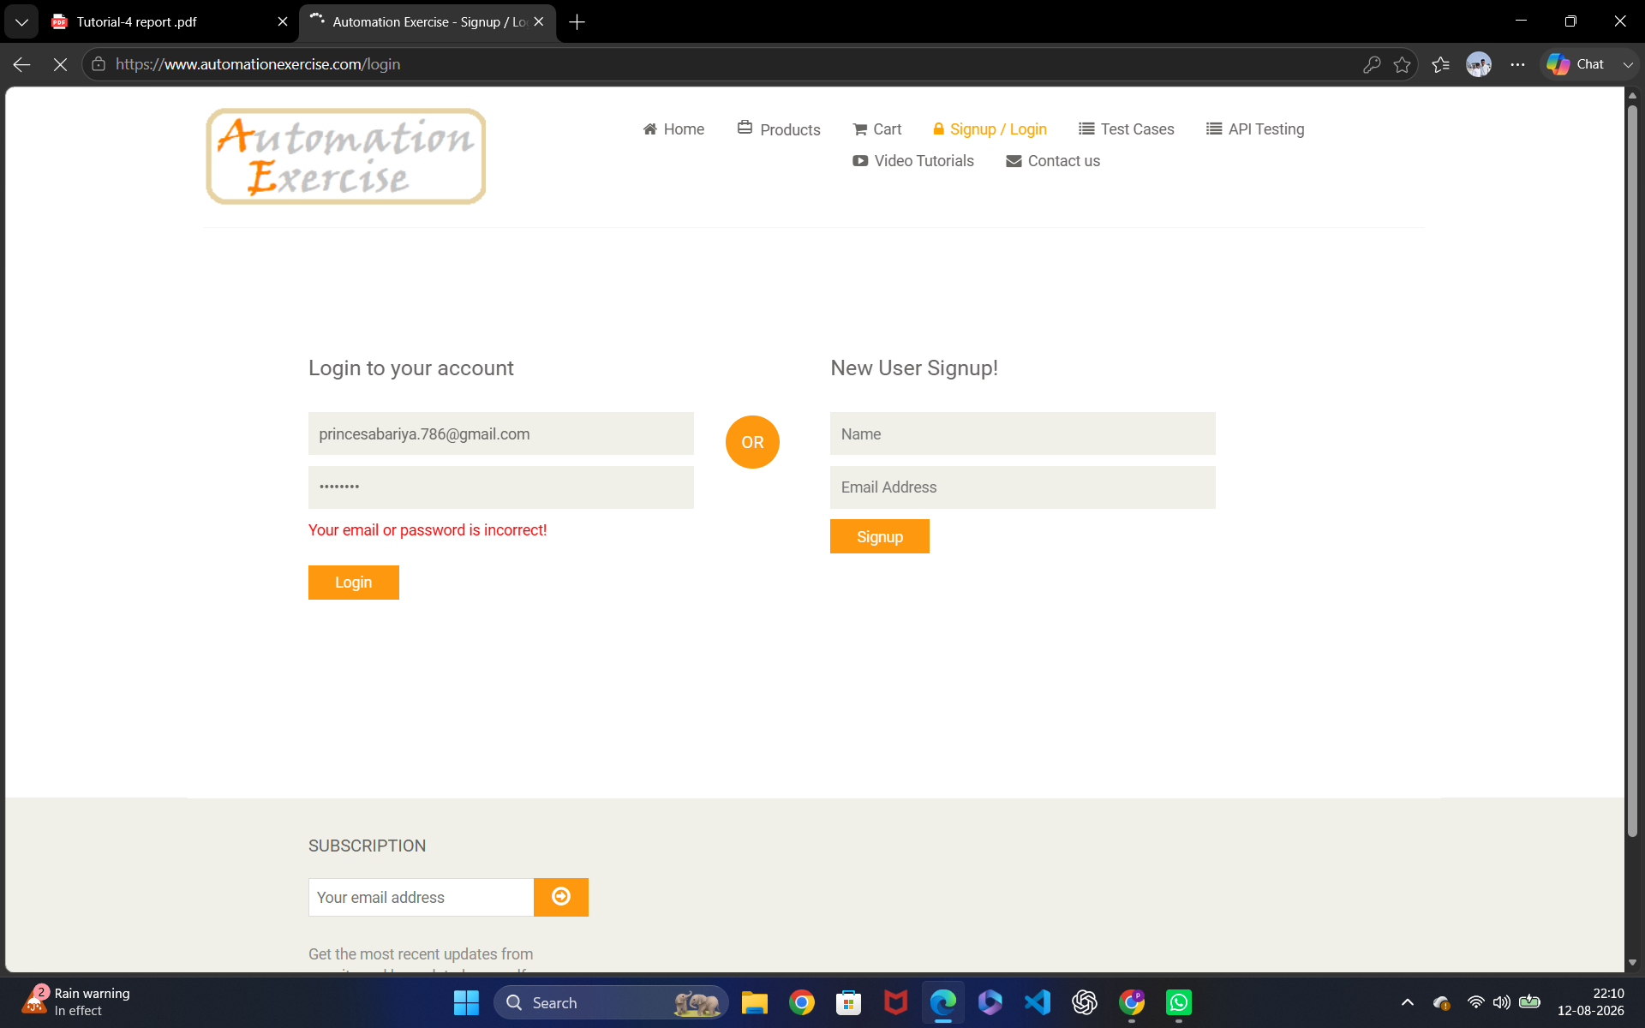

● Scenario ID: 4

Scenario:Blank Email
Test Steps:
1. Blank email
2. Enter password
3. click Login

Screenshots:-

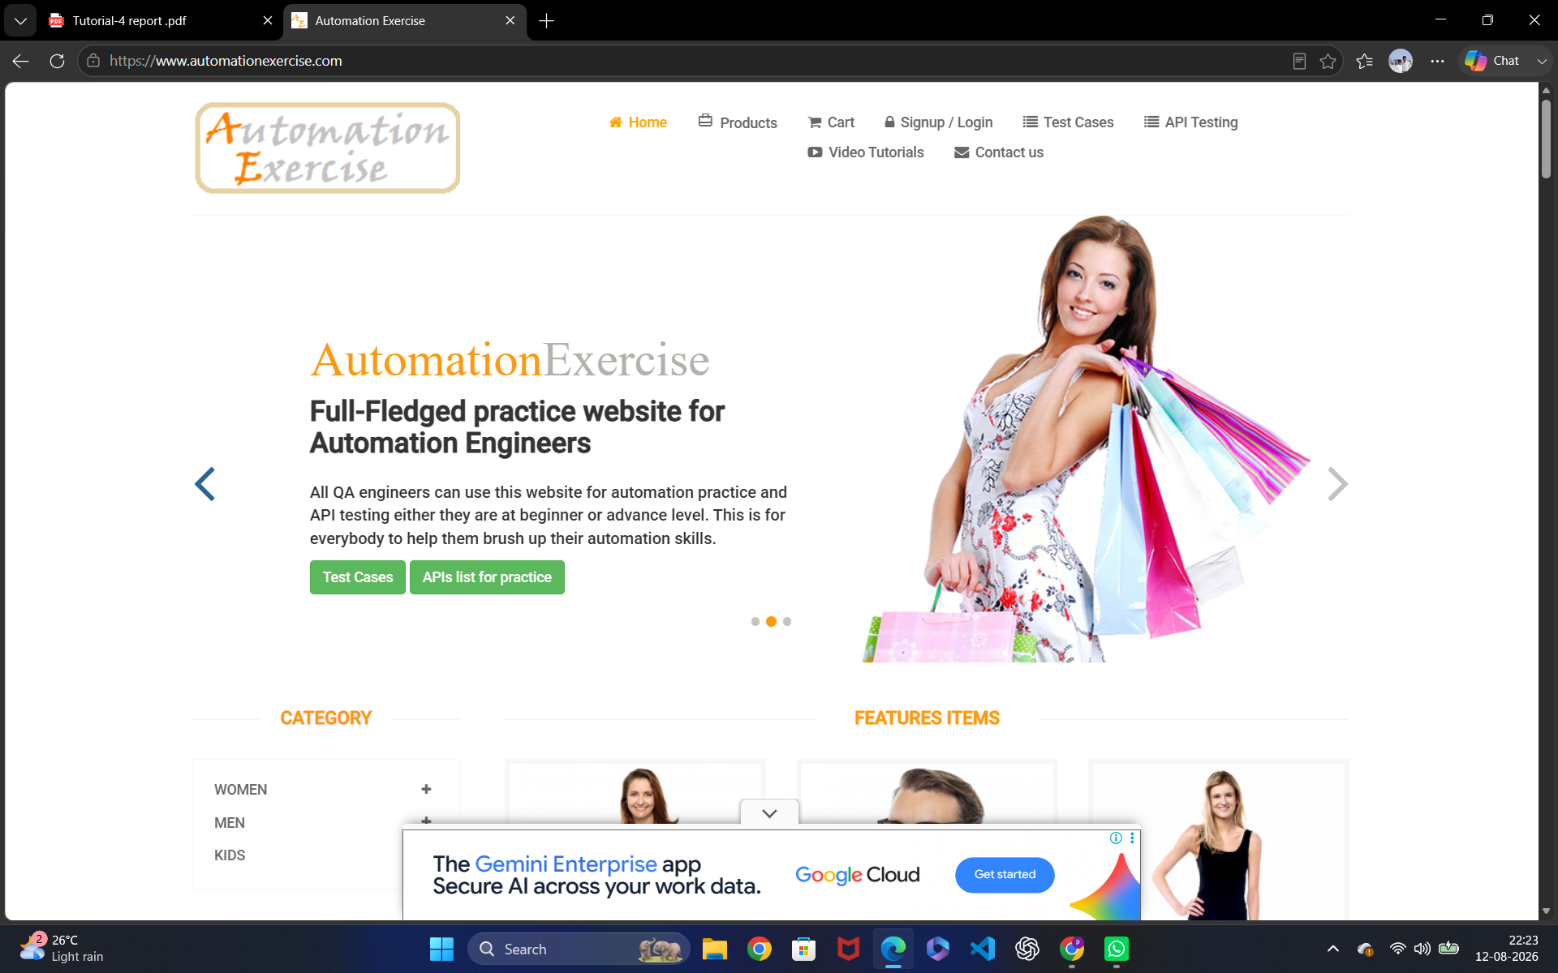
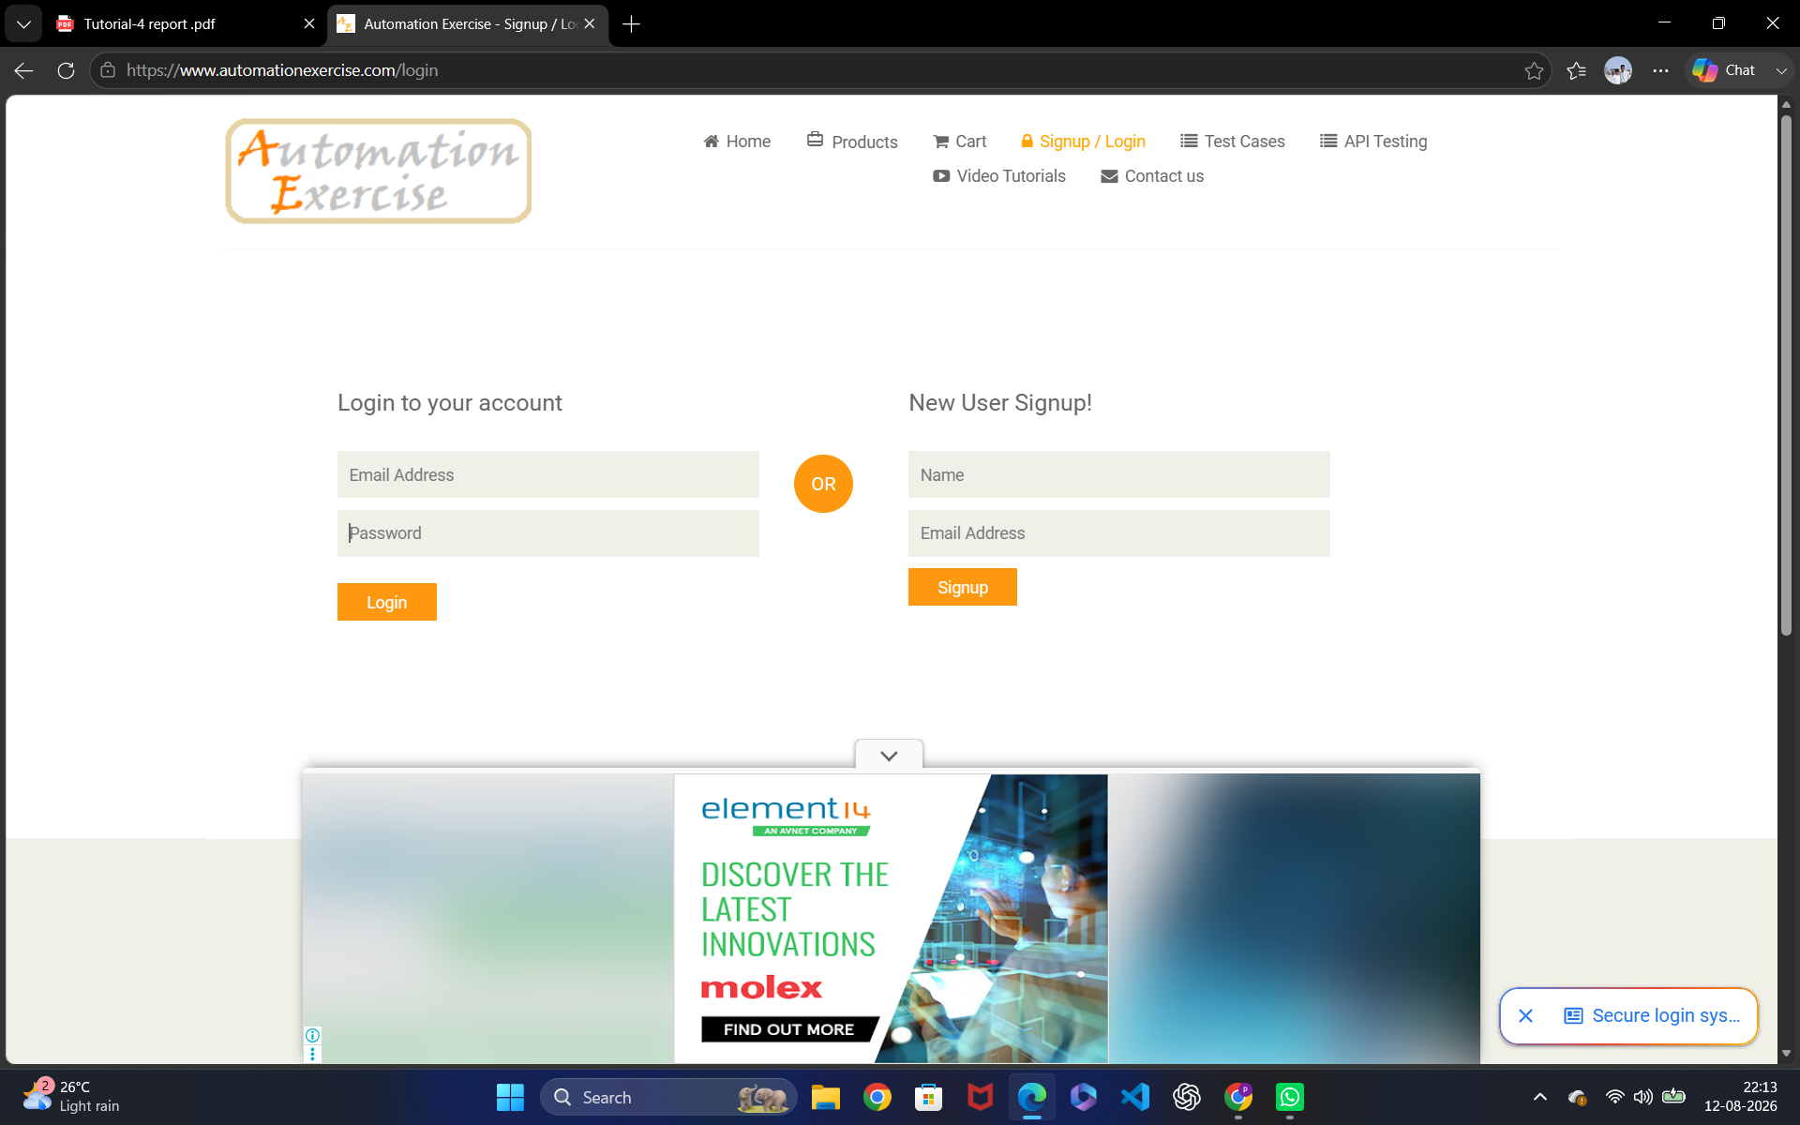

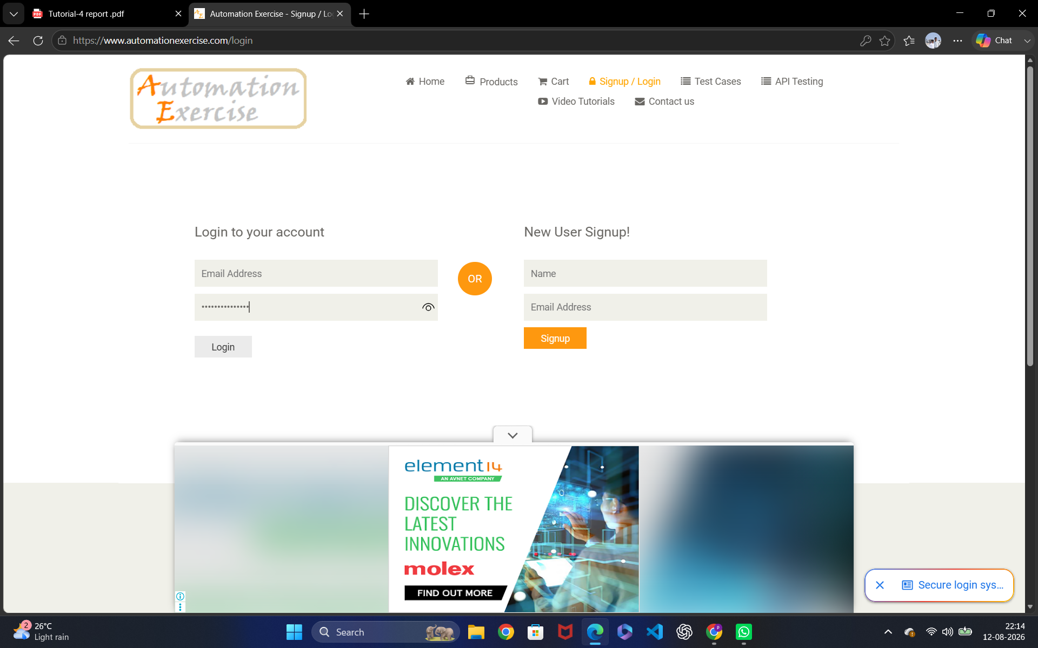

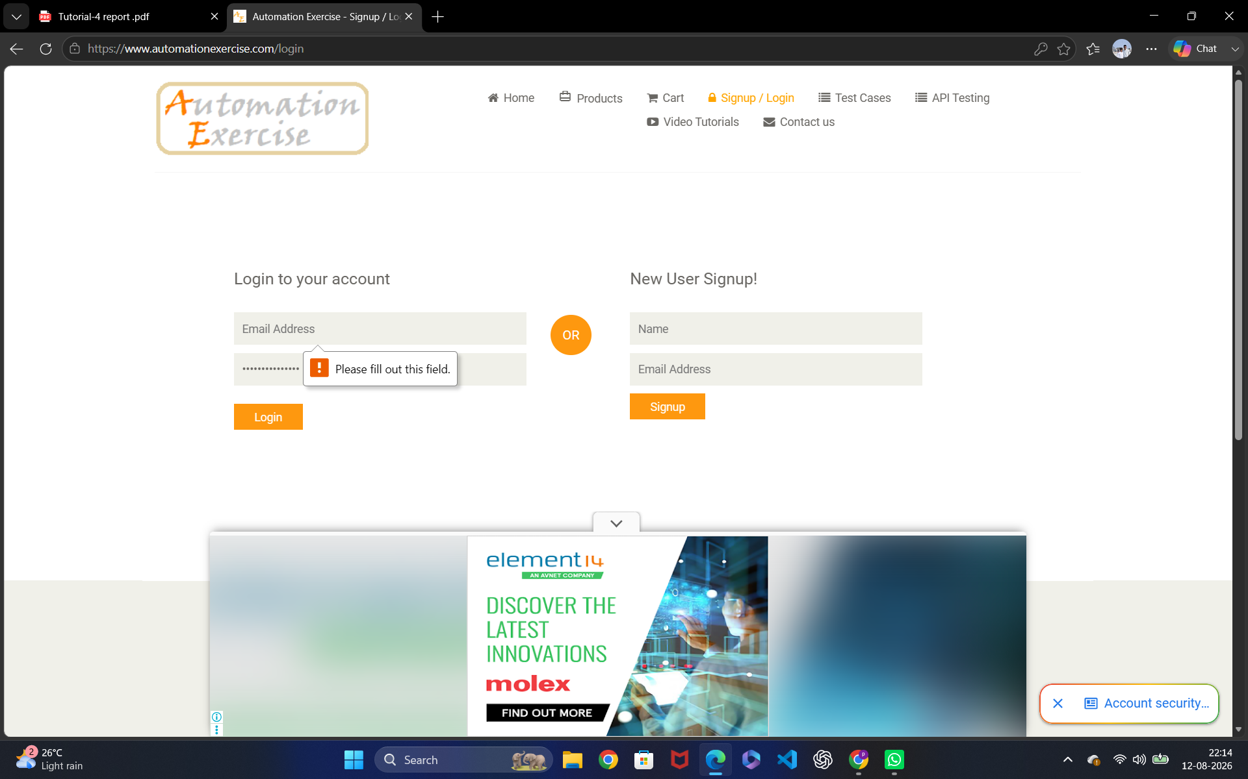

● Scenario ID: 5

Scenario: Blank Password

Test Steps:
1. Enter email
2. Blank password
3. click Login

Screenshots:-

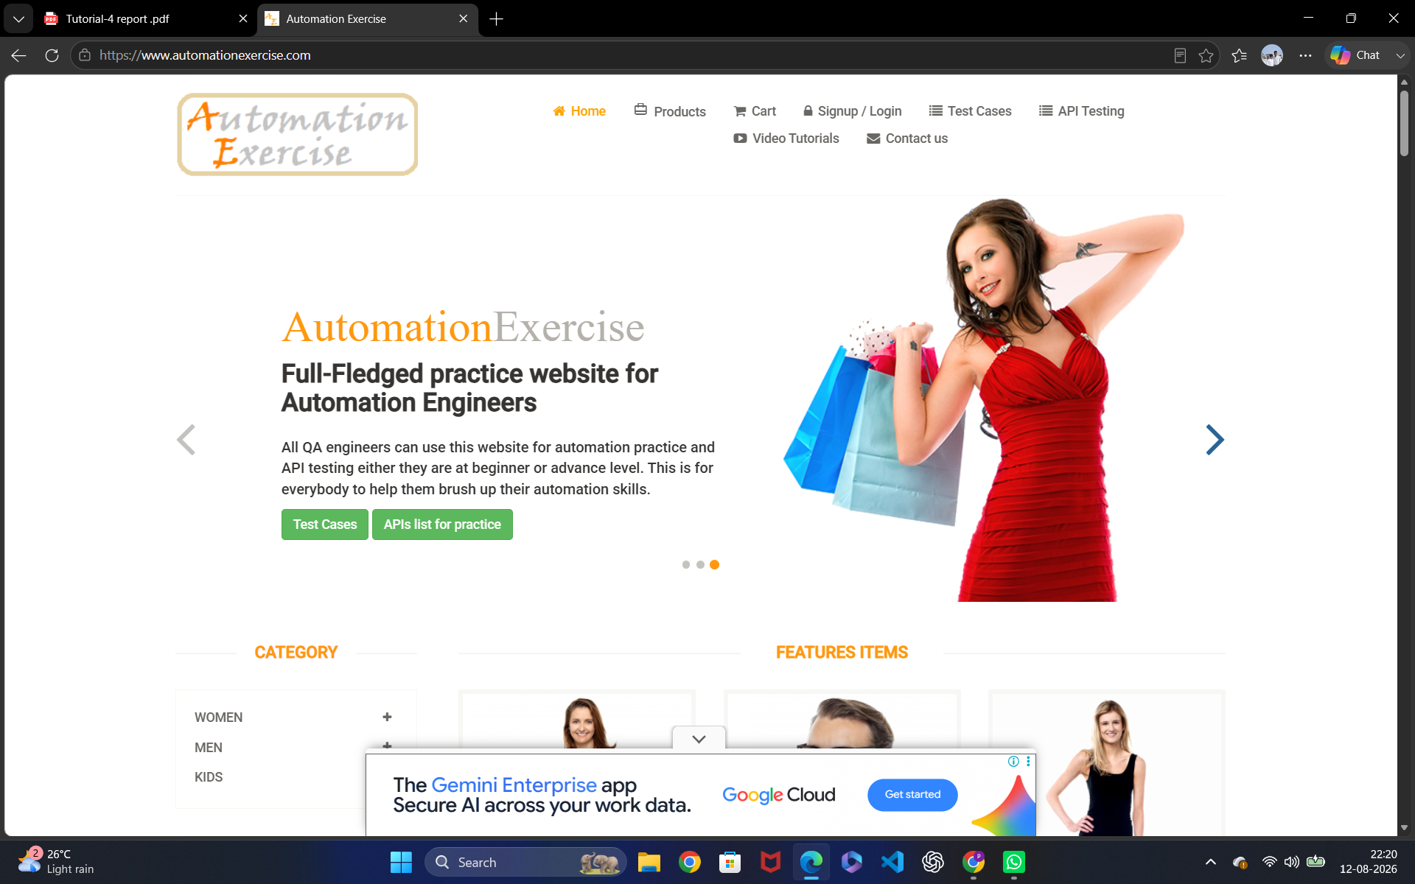

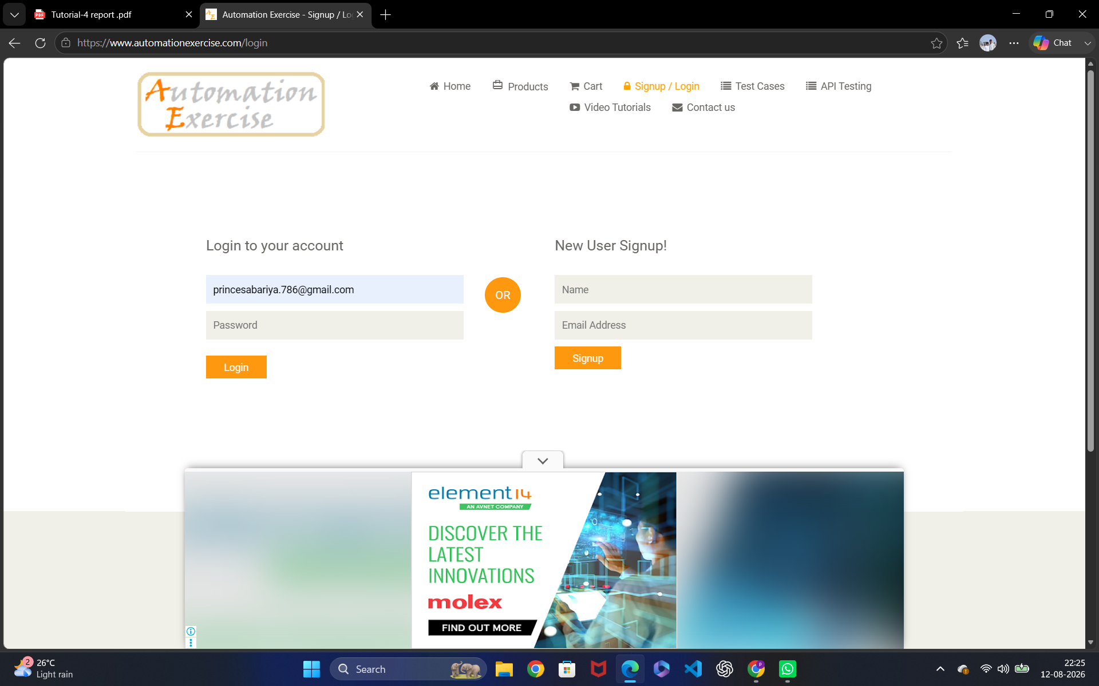

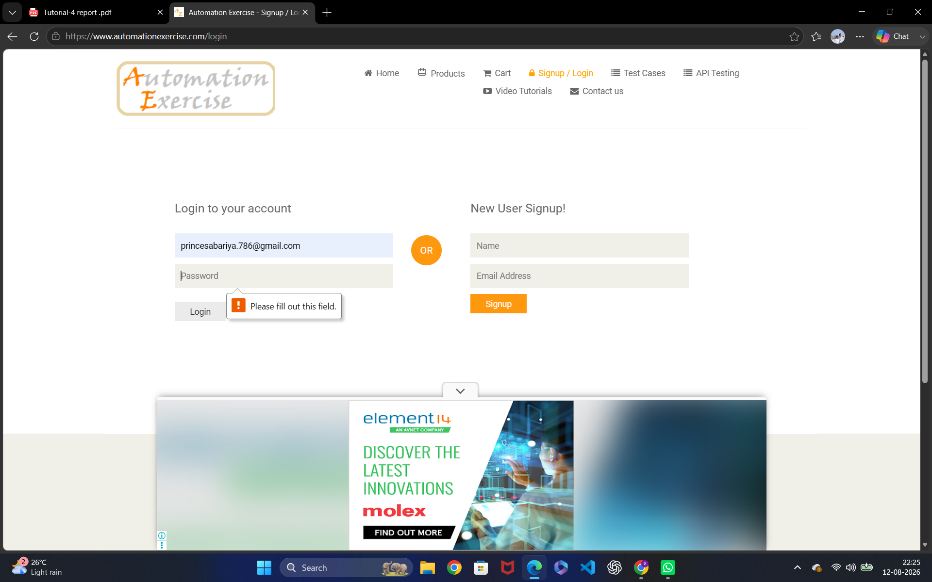

● Scenario ID: 6

Scenario: Email and password both Blank

Test Steps:
1. Open the website
2. Blank email
3. blank password
4. click Login

Screenshots:-

